**Protein-protein interaction network in budding yeast**

**Dataset**:   **Yeast**

Network with 2361 vertices and 7182 edges (536 loops)

**Background**

 Interaction detection methods have led to the discovery of thousands of interactions between proteins, and discerning relevance within large-scale data sets is important to present-day biology. The dataset consists of protein-protein interaction network described and analysed.

Initial Visualization

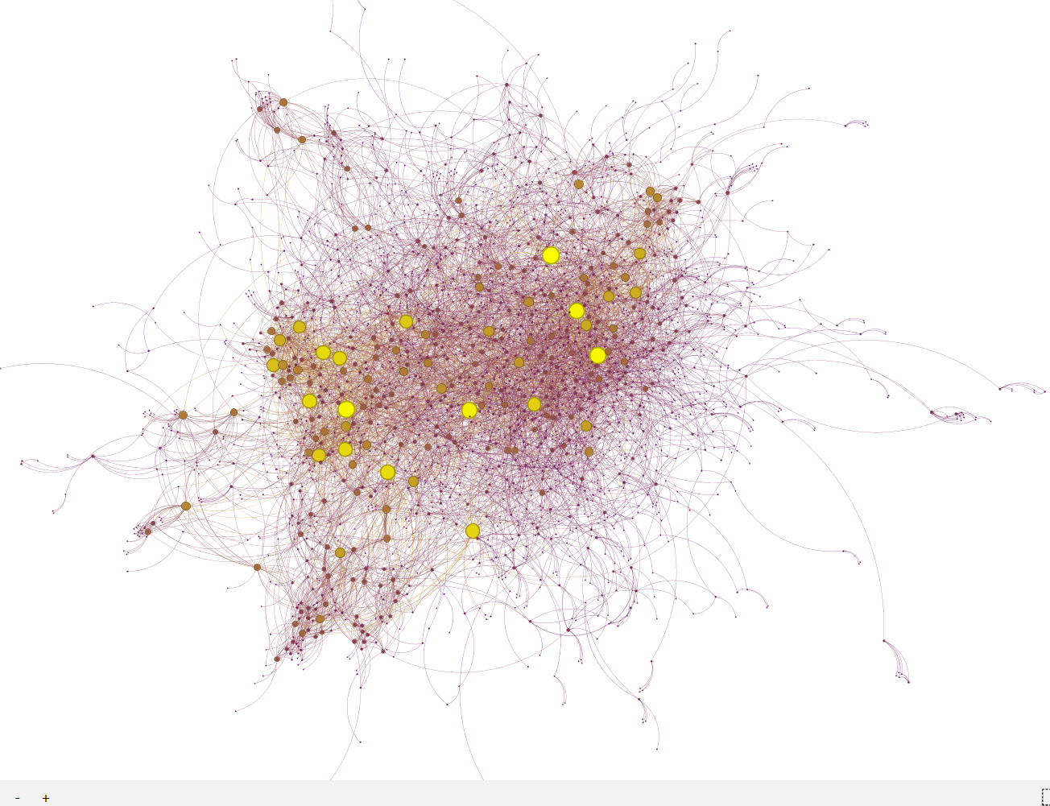

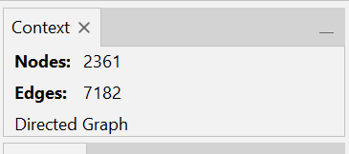

Layout Algorithms

Force atlas

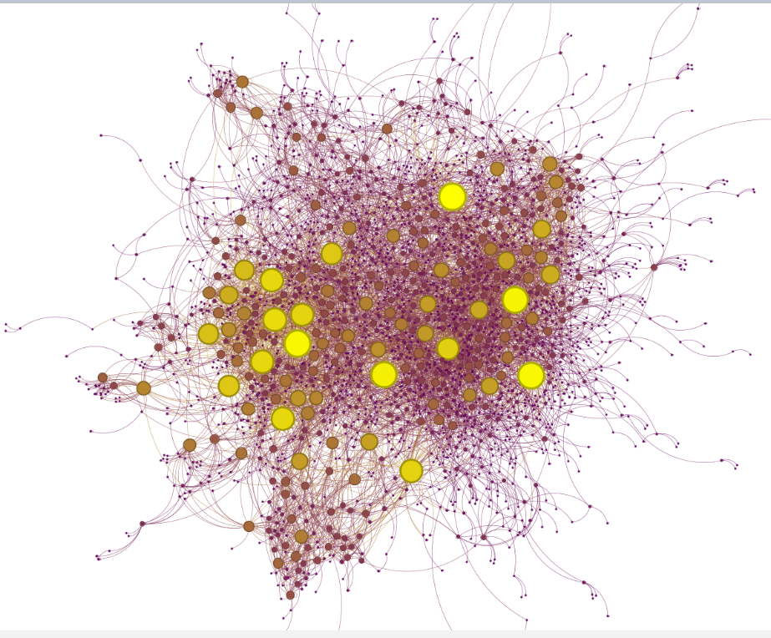The Force Atlas layout in Gephi simulates a physical system where nodes repel each other while edges act like springs, resulting in a visually balanced network. For the Yeast PPI network, this layout effectively clusters related proteins, making it easier to show functional groups and key interactions.

Label adjust.

The Label Adjust layout in Gephi refines the positioning of labels to reduce overlap and enhance readability. In the Yeast PPI network, using Label Adjust ensures that protein names or identifiers are clearly visible, even in densely connected areas, making the network easier to interpret.

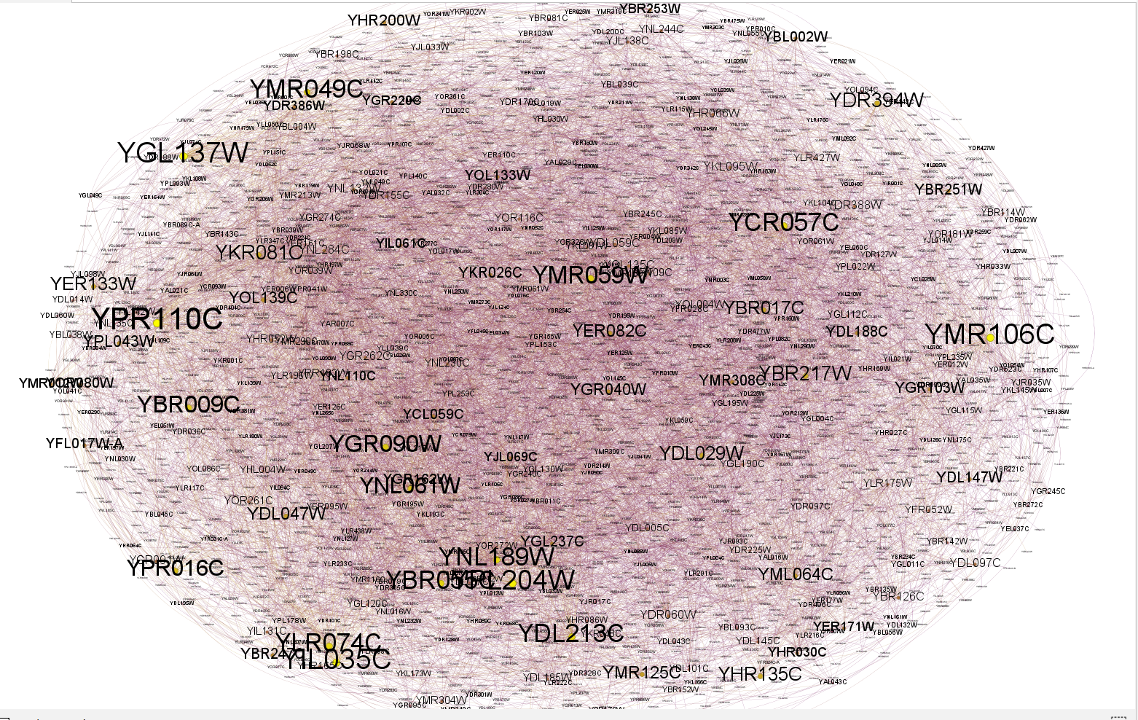

**Basic Statistics**

Data Laboratory

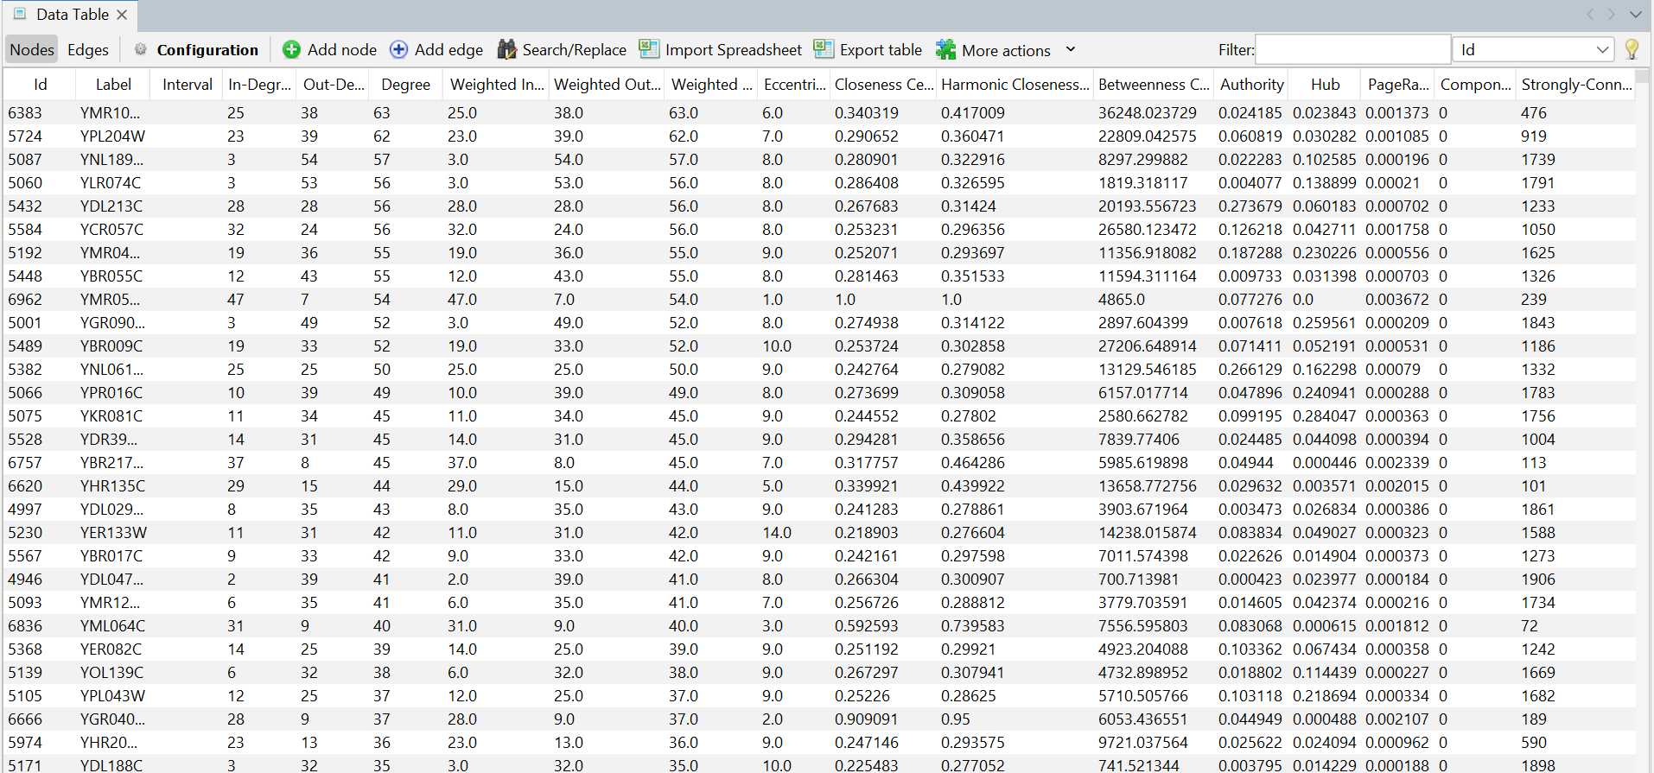

Average density

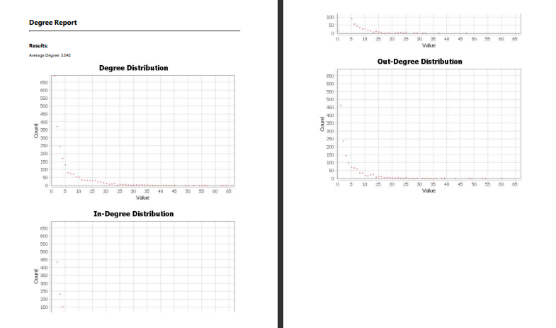

Closeness centrality

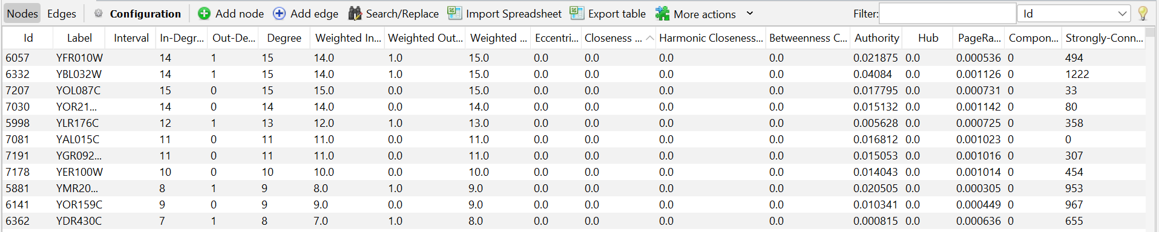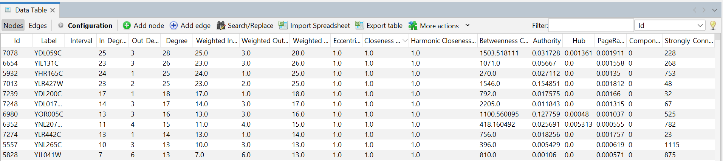

Betweenness centrality

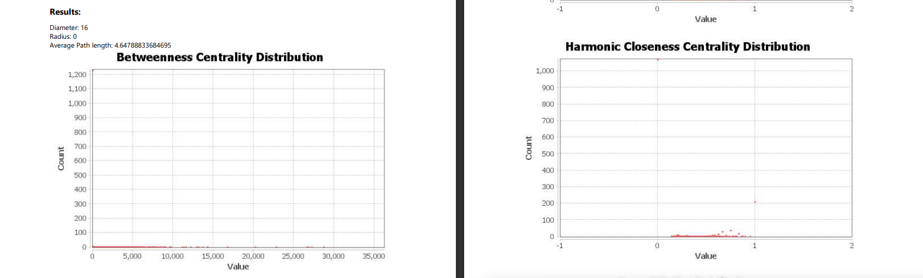

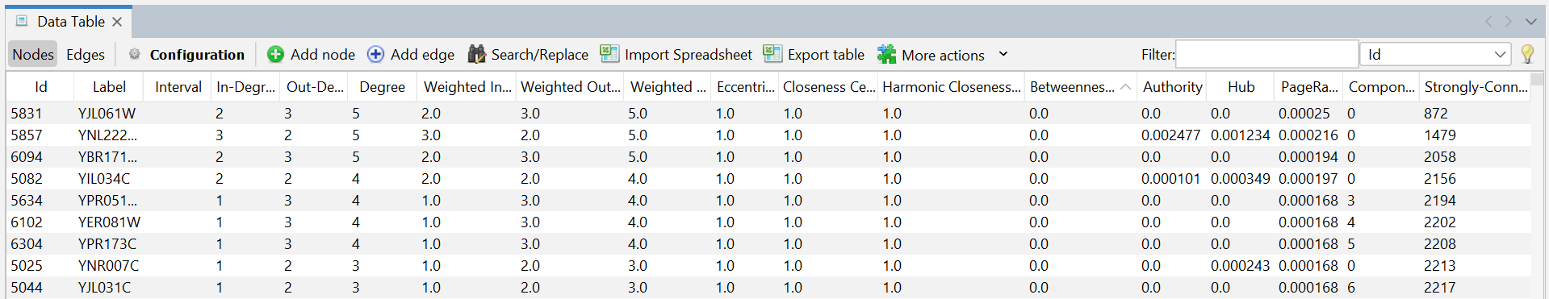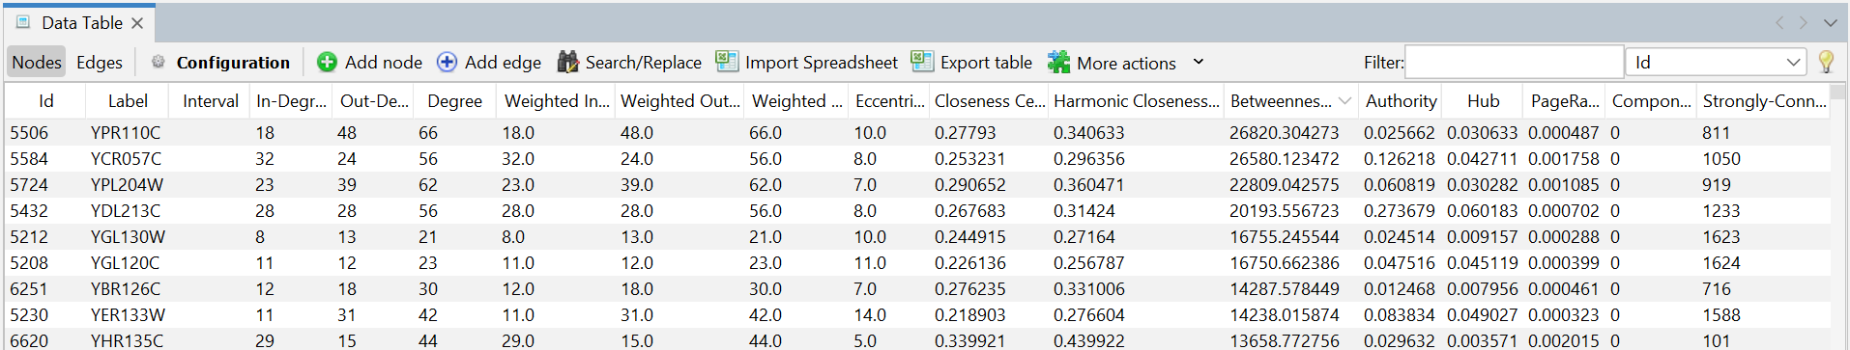

Based on degree

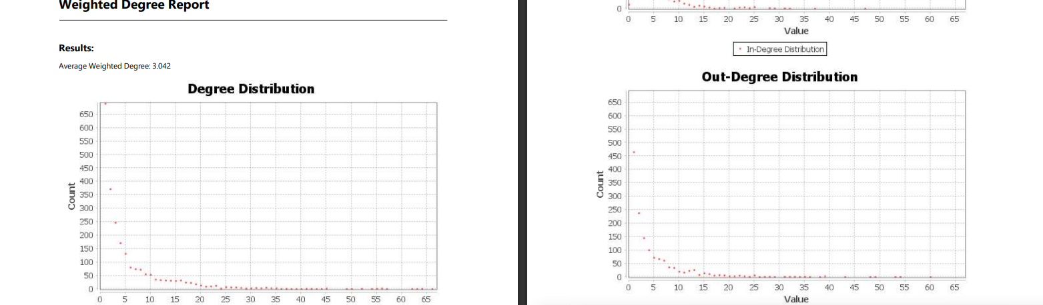

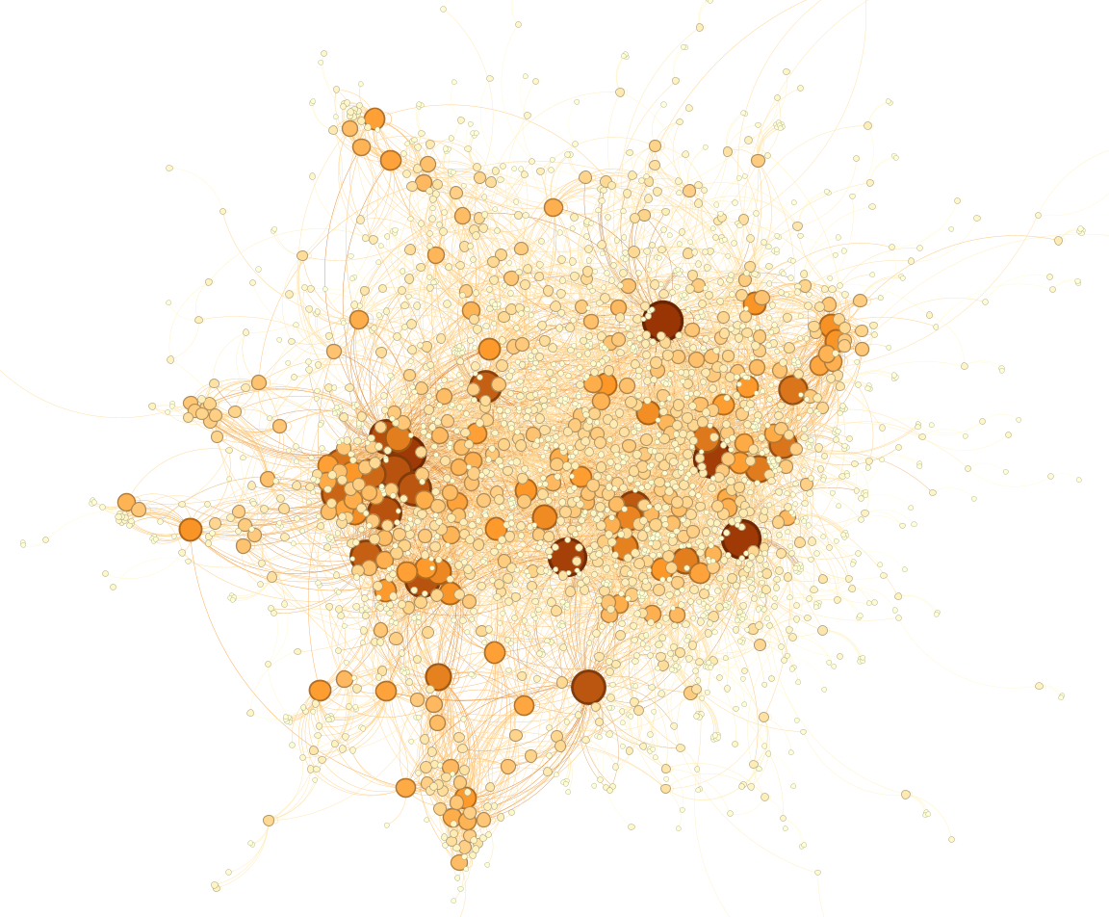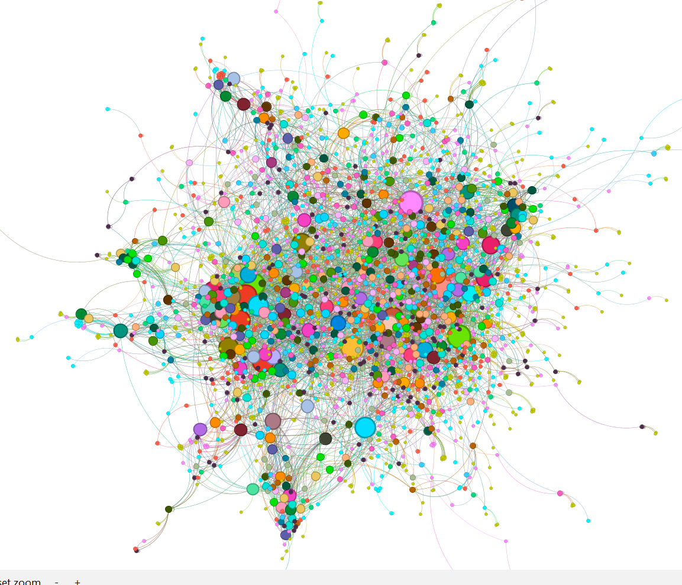

**1. Calculate Degree:**

* Go to the "Statistics" tab.
* Run the "Degree Distribution" algorithm to calculate the degree of each node.
* The degree values will be stored as a new attribute in the node table.

**2. Styling Nodes by Colour (Degree):**

* Switch to the "Overview" tab.
* In the "Appearance" panel, select the "Nodes" tab and click the colour palette icon.
* Choose "Attribute" from the drop-down, then select "Degree" as the attribute.
* Gephi will apply a colour gradient based on node degree.

**3. Styling Nodes by Size (Degree):**

* In the "Appearance" panel, select the "Size" icon under the "Nodes" tab.
* Choose "Attribute" and then select "Degree."
* Adjust the size range to reflect the degree values.

Betweenness centrality

**1. Calculate Centrality:**

* Go to the "Statistics" tab.
* Run the "Betweenness Centrality" algorithm to calculate the centrality of each node.
* The centrality values will be stored as a new attribute in the node table.

**2. Styling Nodes by Colour (Centrality):**

* Switch to the "Overview" tab.
* In the "Appearance" panel, select the "Nodes" tab and click the colour palette icon.
* Choose "Attribute" from the drop-down menu, then select "Betweenness Centrality" (or other centrality measures).
* Gephi will apply a colour gradient based on centrality values.

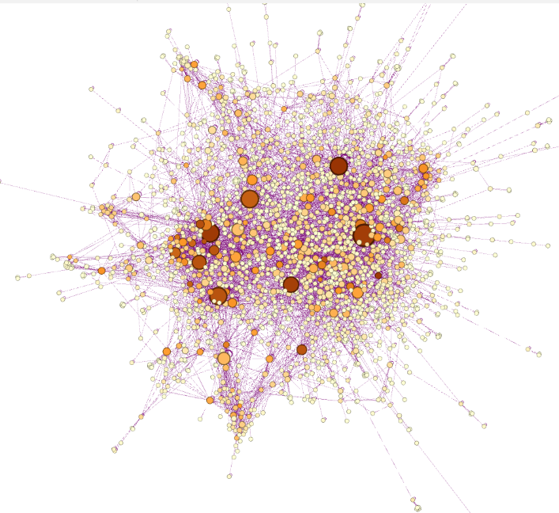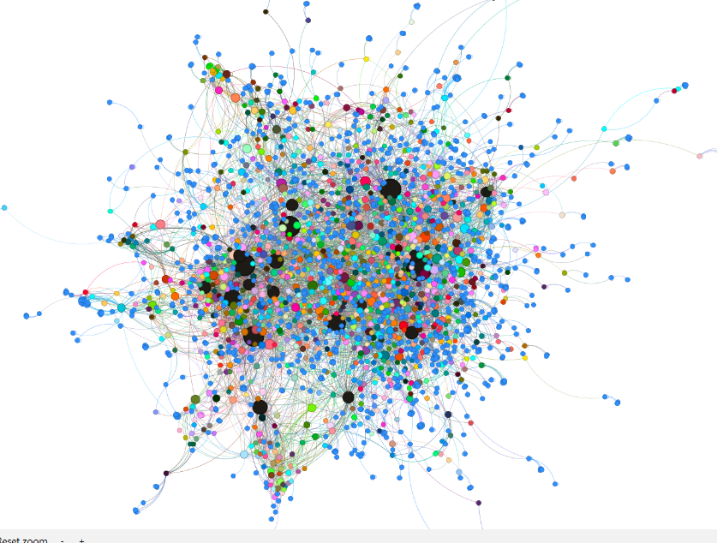

**3. Styling Nodes by Size (Centrality):**

* In the "Appearance" panel, select the "Size" icon under the "Nodes" tab.
* Choose "Attribute" and select "Betweenness Centrality."
* Adjust the size range to reflect the centrality values.

**4. Styling Edges by Colour:**

* If you want to style edges based on the centrality of connected nodes, select the "Edges" tab in the "Appearance" panel.

**Community connect.**

**Community detection, also known as graph clustering, is a technique used to show groups of nodes (communities) that are more densely connected internally than with the rest of the network. In the context of the Yeast Protein-Protein Interaction (PPI) network, detecting communities can help show protein complexes or functional modules, offering insights into the biological organization of the network.**

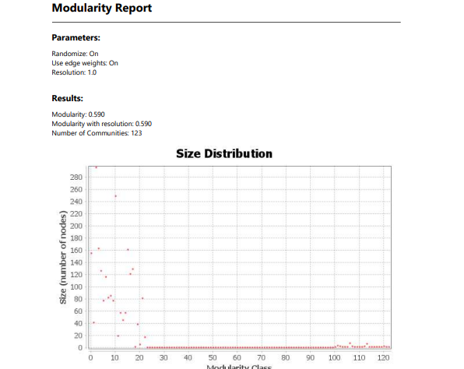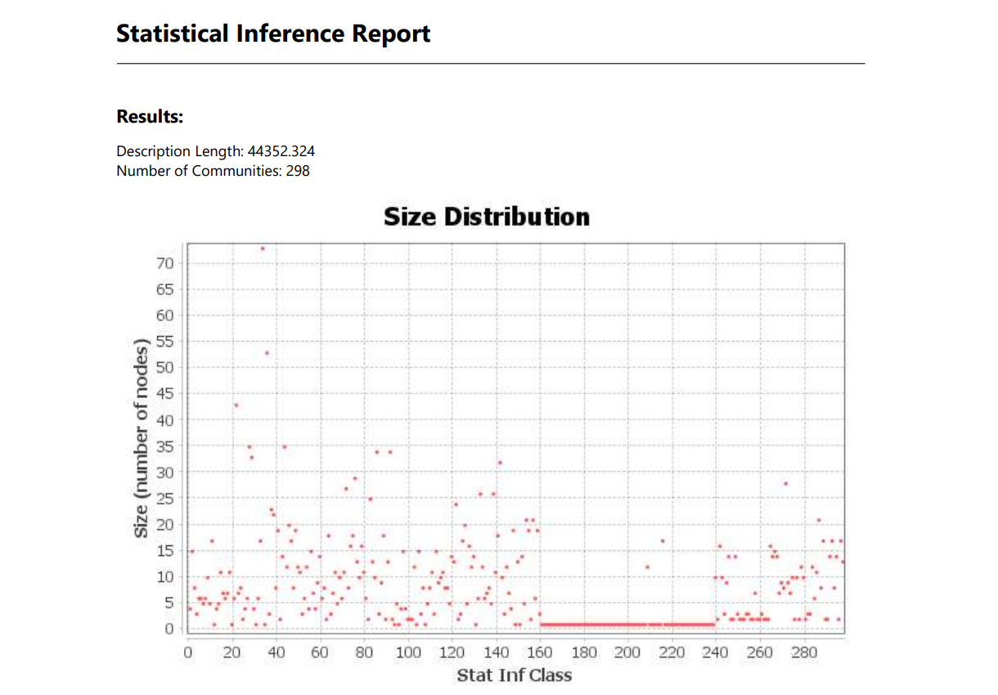

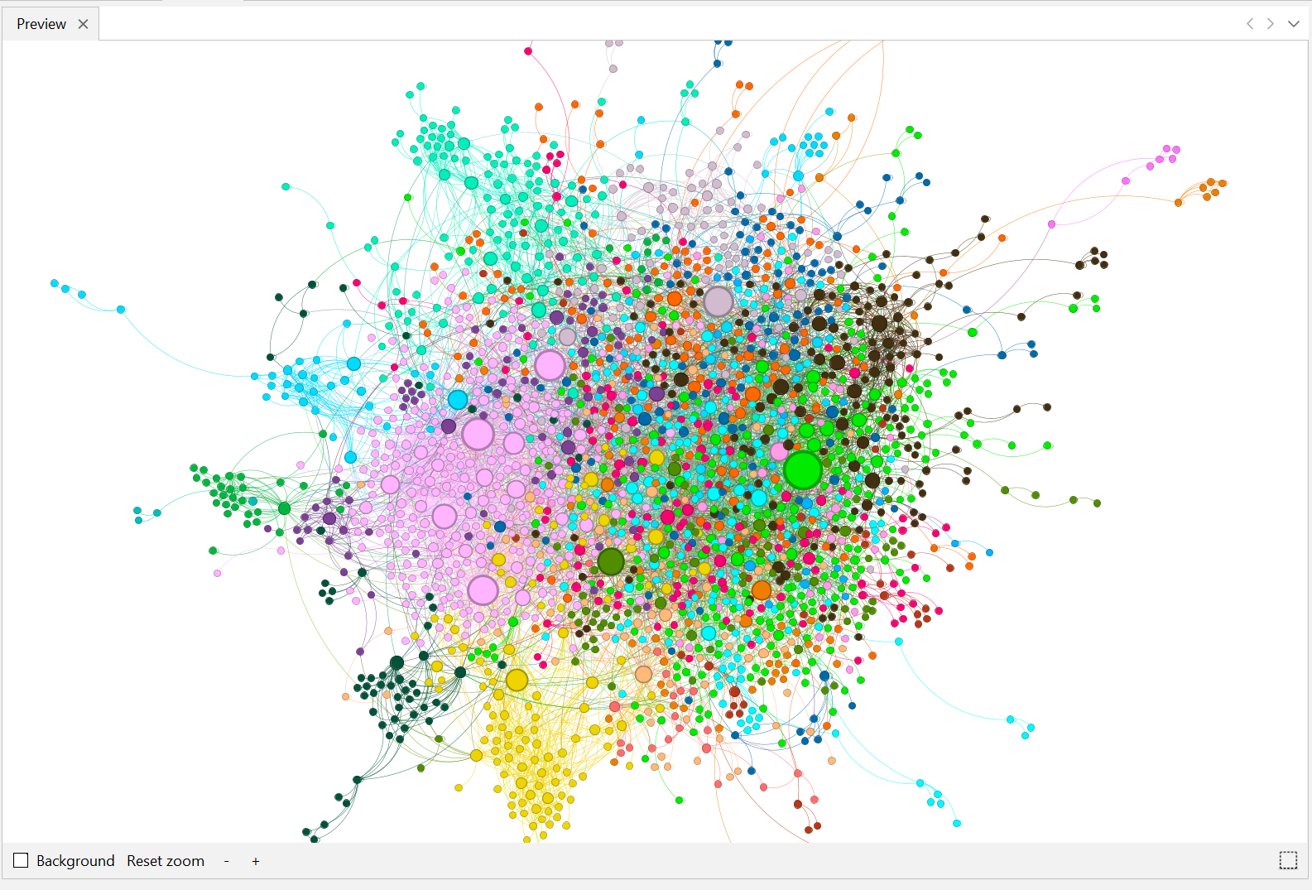

**1. Run the Community Detection Algorithm:**

* **Go to the "Statistics" tab in Gephi.**
* **Select the "Modularity" algorithm, which is commonly used for community detection.**
* **Click "Run." The algorithm will compute and assign a modularity class (community) to each node based on their connectivity.**

**2. Visualize Communities:**

* **Switch to the "Overview" tab.**
* **In the "Appearance" panel, select the "Nodes" tab and click on the colour palette icon.**
* **Choose "Partition" and then select "Modularity Class" from the drop-down menu.**
* **Gephi will colour each node based on its community, with distinct colours representing different communities.**

**3. Adjust Node and Edge Appearance:**

* **You can further adjust node size based on degree or centrality within each community to highlight important nodes.**
* **Edges can also be styled to differentiate connections within communities versus between communities.**

**4. Analyse Community Structure:**

* **Review the resulting visualization to show significant communities.**
* **Use the "Data Laboratory" to explore the nodes and their assigned communities.**
* **Optionally, apply filters to focus on specific communities or compare their structures.**

**Use Cases for In-Degree and Out-Degree Filtering:**

* Identify Key Influencers: Nodes with a high out-degree might be influential proteins that interact with many others.
* Highlight Receptors or Hubs: Nodes with a high in-degree might be key receptors or central hubs in the network, receiving many interactions.
* Focus on Specific Network Regions: Filtering helps reduce complexity, allowing you to focus on areas of the network that are most relevant to your analysis.

**Degree above 5**

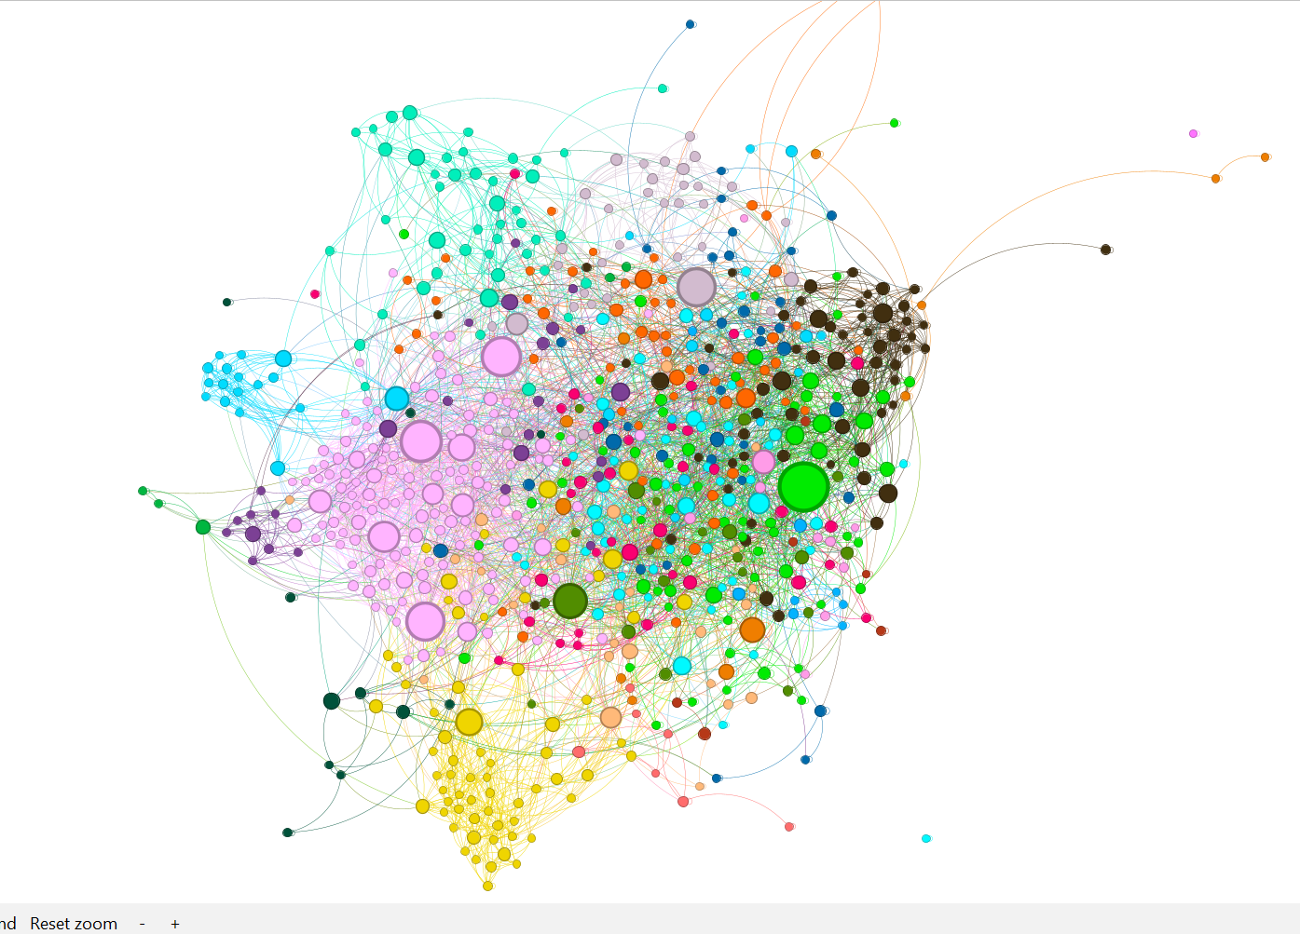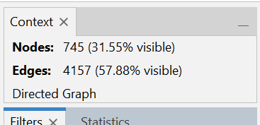

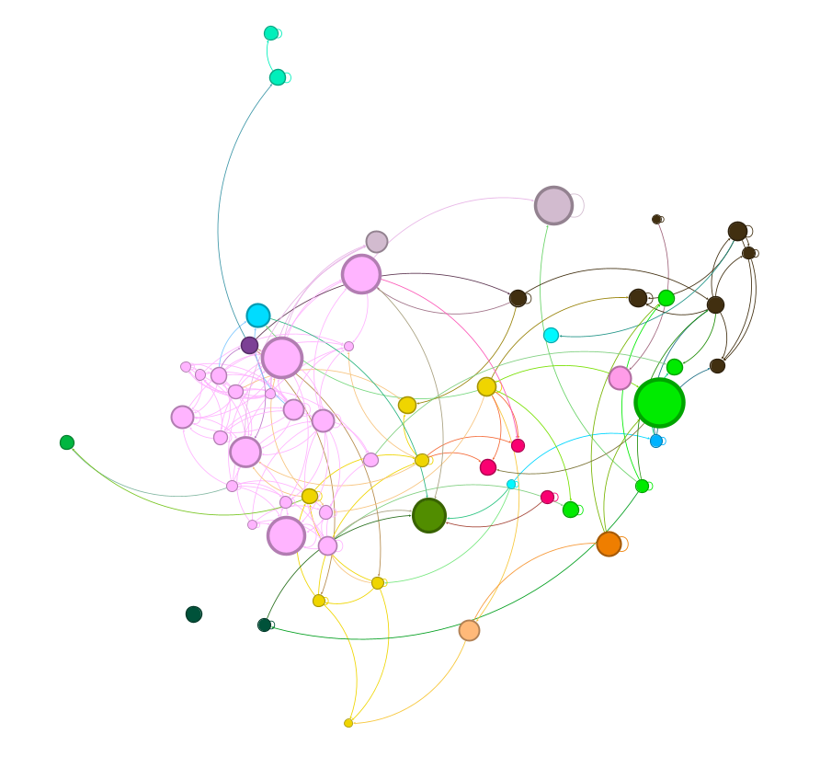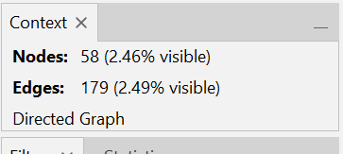

**0ut degree 10-60**

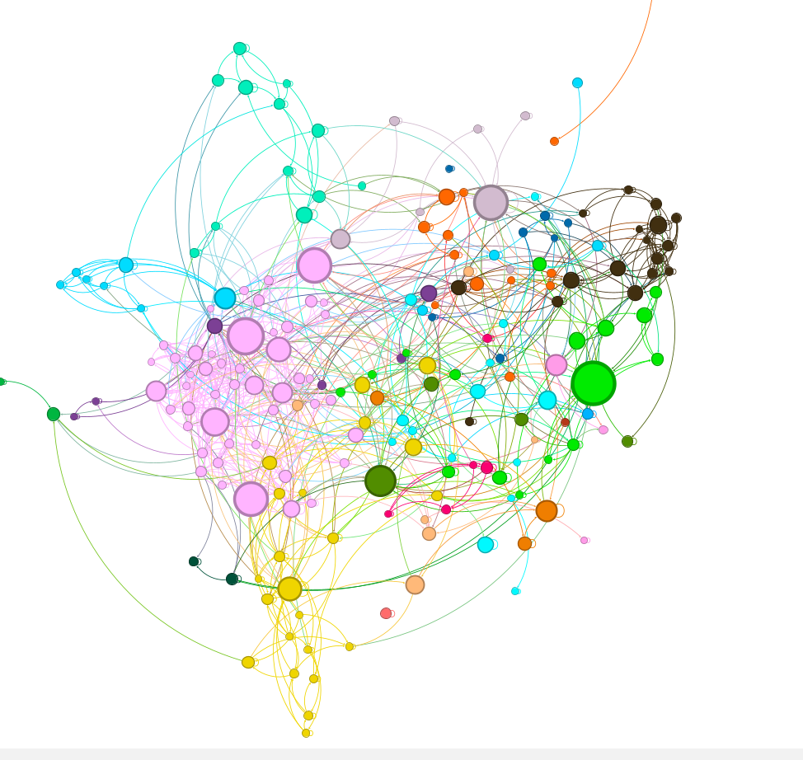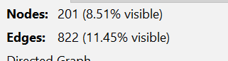

**indegree 10-47**

